Stack In Java :
The stack is a linear data structure that is used to store the collection of objects. It is based on Last-In-First-Out (LIFO).
The stack data structure has the two most important operations that are push and pop.
The push operation inserts an element into the stack and pop operation removes an element from the top of the stack
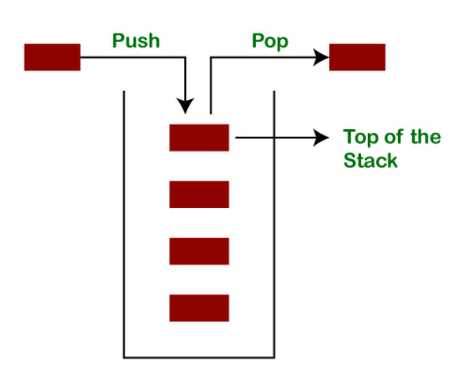
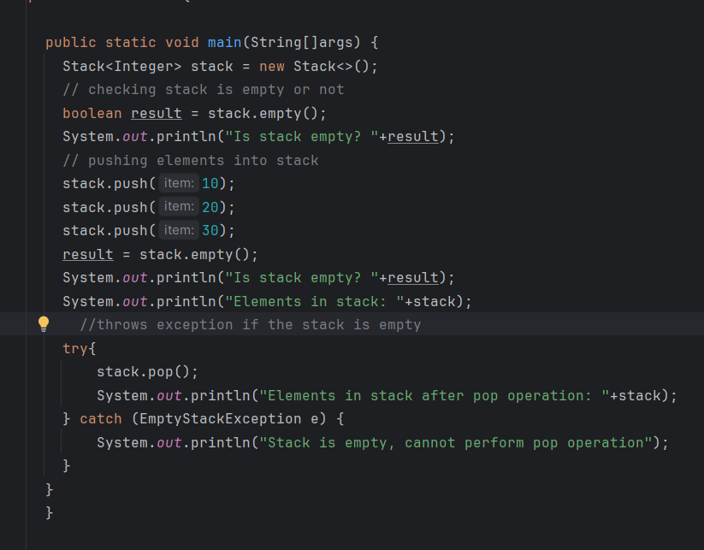
Output :
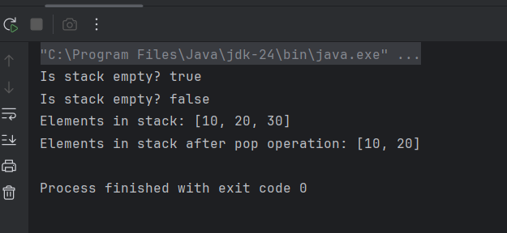
Here you can see the LIFO procedure applied on stack the last element 30 was popped out.
Stack Class peek() Method
The peek() method returns the top element of the stack without removing it
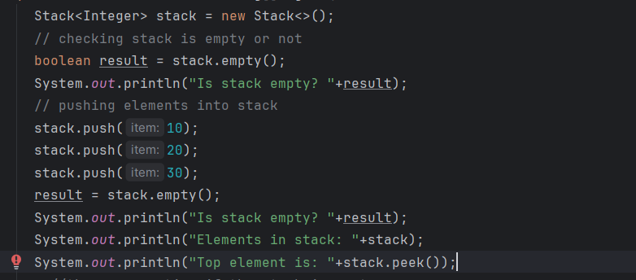
Output :
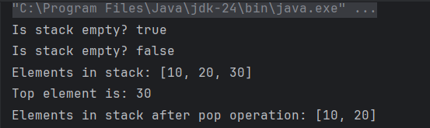
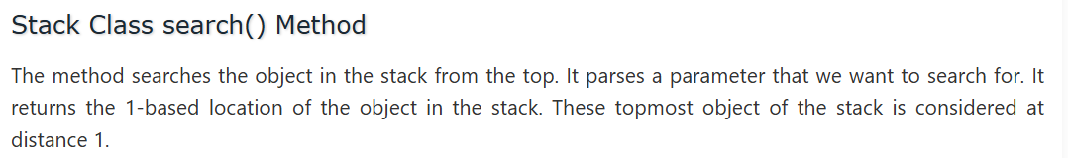
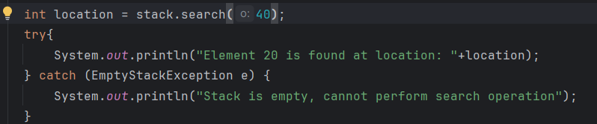
If the element is not found at stack location will be returned as -1.
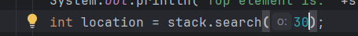
Since 30 is present at top it will be returned as 1 .
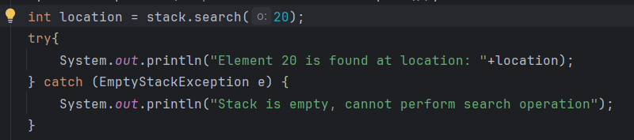
Since 20 is present at position no 2 in stack if we start from top will return 2 .
--------------------------------------------------------------------------------------------------------------------
stack.size() will return the size of stack.
---------------------------------------------------------------------------------------------------------------------
For Each loop in stack you can use in this way.
-------------------------------------------------------------------------------------------------------------------

